DERE
Baranja, Hungary

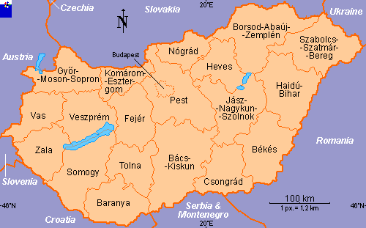
In the 18th century, the town of Pécs (Pećuh) was the most important center of the Croatian minority in Hungary, especially the Bosanski Hrvati, Bošnjaci and Šokci. They lived in the southern part of Hungary in the region of Baranja. They all spoke the “Ikavian” dialect, despite small variations in their customs and costumes. Today opportunities for dance surround special occasions, like weddings, pre-Lenten festivities and the annual harvest. Željko was researching Croatian culture in the summer of 1992 around the city of Pécs.

TRANSLATION: Little kid / boy or girl /

PRONUNCIATION: DEH-REH

MUSIC: CD “BAŠTINA HRVATSKOG SELA”, Band 1

FORMATION: Closed circle, alternating M and W, facing ctr.

HANDS: Hands joined in V-position

STEPS: DERE Grapevine: Walk L-R-L /Facing L of ctr. and moving in
RLOD (L)/ & step R behind L
Side-close: Step L to L; close R beside L /no wt on R
Step R to R; close L beside R/ no wt on L
IGRALA BI DERE
- Side-close:
Meas 1 - 4 2 side-close steps sdwd L/& 1 sdwd R/& 1 sdwd L
5 - 8 Repeat with opp ftwk moving sdwd R
9 -12 Repeat meas. 1 - 4
Drmeš
Same ftwk as side-close steps EXCEPT each step is a “drmeš“
Meas 1: Moving sdwd R - step R to R with knees bent slightly (down) (ct 1); close L beside R and bounce 2 times on both ft (up-up) (cts 2, &) most of wt on L (ct &). (S, Q, Q)
When moving sdwd L use opp ftwk

Meas 1 Step on L and step on R behind L
Meas 2 Step L, R, L in place (Q, Q, S)
Meas 3 Hop-step-step – starts with L foot and move slightly
sdwd R
Meas 4 Step R, L, R in place (Q, Q, S)
C) Meas 1-4 4 step-close steps moving sdwd L
Meas 5-8 4 single “drmeš “steps /R, L, R, L/ (S, Q, Q)
Meas 9-16 Repeat meas. 1 – 8 with opp ftwk & direction

STYLE: The drmeš (shaking dance) is done flat-footed with small steps and movements. All ftwk is rather stiff-legged and flatfooted.

Dere, Page 2 of 3

Meas Music: 2/4 meter PATTERN

DERE (Vocal)

INTRODUCTION: None

FIG. I: GRAPEVINE

1-4 No action (Second and third verse Grapevine step)

5-8 Walk L-R-L / Facing L of ctr. and moving in RLOD (L)/ & step R behind L
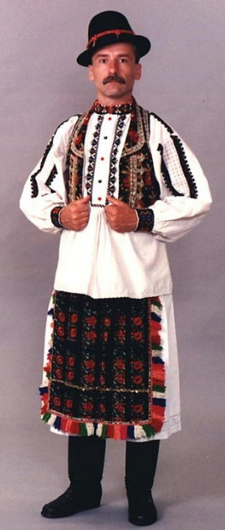
FIG. II: SIDE – CLOSE

9 Facing ctr - Step L to L.

10 Close R beside L /no wt on R.

11 Step R to R

12 Close L beside R/ no wt on L

  - Repeat meas. 9-12 one more time

→ REPEAT FIG. I-II twice more. (3 in all)



IGRALA BI DERE (Instrumental & Vocal)
A) SIDE - CLOSE:

1-4 2 side-close steps sdwd L & 1 sdwd R & 1 sdwd L /1 side-close step per meas.

  - Repeat meas. 1- 4 with opp ftwk and moving in opp direction

  - Repeat meas. 1- 4

DRMEŠ*** Same ftwk as side-close steps EXCEPT each step is a “drmeš“

  - Moving sdwd R - step R to R with knees bent slightly (down) (ct 1); close L beside R and bounce 2 times on both ft (up / up) (cts 2, &) most of wt on R (ct &). (S, Q, Q).
Repeat one more time – total of 2 drmeš steps sdwd R

3 Repeat meas. 1 with opp ftwk and moving in opp direction (L)

4 Repeat meas. 1

5-8 Repeat meas. 1 – 4 with opp ftwk and direction

9-12 Repeat meas. 1 – 4

Dere, Page 3 of 3

B)
1 Step on L and step on R behind L

2 Step L, R, L in place (Q, Q, S)

3 Hop-step-step – starts with L foot and move slightly sdwd R

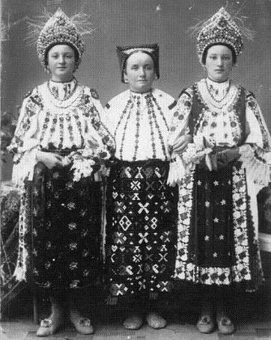
4 Step R, L, R in place (Q, Q, S)

5-16 Repeat meas. 1-4 3 more times (4 in all)

C)
1-4 4 step-close steps moving sdwd L

5-8 4 single “drmeš“steps /R, L, R, L/ (S, Q, Q)

9-16 Repeat meas. 1-8 – moving sdwd R with opp ftwk

*PATTERN: A - B - A - B

C

B - A - B

C

A - B - A


Dere, dere, dere, ko ti u{e pere? Nekad tata, nekad mama, nekad i ja sama.
Dere, dere, dere, ko ti ruke pere?
Dere, dere, dere, ko ti noge pere?
Little kid, little kid, who washes your ears? Hands? Feet? Sometimes daddy, sometimes mummy, sometimes I myself.
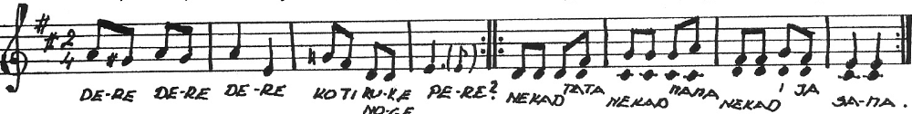

Igrala bi’ dere, ne smijem od Pere, Pero }e me tu}i i za kiku vu}i.
Ej, diko moja, mala ludo moja, Ej, sve te varam da }u biti tvoja.
Ej, moja mama i dikina mama, Ej, te dvi prije, grijota {to `ive.

I want to dance, but Pero scares me. Pero will push me around and pull my braid.
Well, my darling, silly of mine, that I’ll be yours is just a lie.
Well, my mother and my dearest, Keep us apart, what a shame.

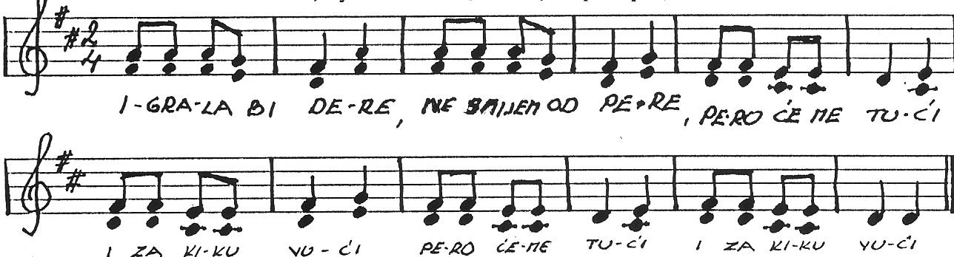

Dance notes by Željko Jergan, 7-04

