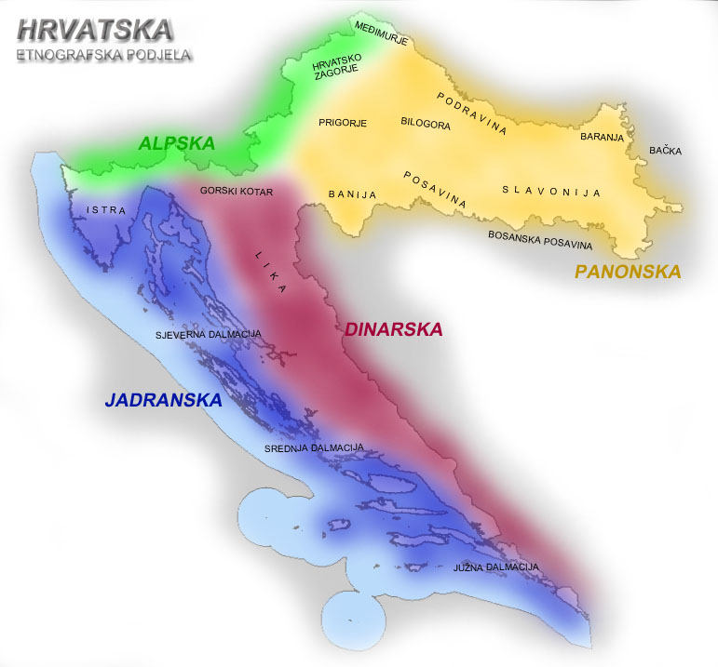
Ethnographic regions of Croatia
"For Croatians, folk traditions are like sacred flames never allowed to expire. They are transmitted from generation to generation, according to long-established rituals nobody would ever dream of changing."

